**NOTE: Blue title means Ensemble + GAN Red title means GAN - AD(Semi-supervised)**

**Ensembles of Generative Adversarial Networks (2016)**

**YaxingWang, Lichao Zhang, Joost van de Weijer**

Computer Vision Center

Barcelona, Spain

**Core idea:**

Three models to implement ensemble into GAN:

1. **Standard Ensemble of GANs (eGANs):** They first consider a straightforward extension of the usage of ensembles to GANs. This is similar to ensembles used for discriminative CNNs which have shown to result in significant performance gains. Instead of training a single GAN model on the data, one trains a set of GAN models from scratch from a random initialization of the parameters. When generating data one randomly chooses one of the GAN models and then generates the data according to that model.
2. **Self-ensemble of GANs (seGANs):** Other than discriminative networks which minimize an objective

function, in a GAN the min/max game results in a continuing shifting of the generative and discriminative network (see also observation 1 above). An seGAN exploits this fact by combining models which are based on the same initialization of the parameters but only differ in the number of training iterations. This would have the advantage over eGANs that it is not necessary to train each GAN in the ensemble from scratch. As a consequence it is much faster to train seGANs than eGANs.

1. **Cascade of GANs (cGANs):** The cGANs is designed to address the problem that part of the data distribution might be ignored by the GAN. The cGANs framework is designed to train GANs to effectively push the generator to capture the whole distribution of the data instead of focusing on the main mode of the density distribution. It consists of multiple GANs and gates. Each of the GAN trains a generator to capture the current input data distribution which was badly modeled by previous GANs. To select the data which is re-directed to the next GAN we use the fact that for badly modeled data x, the discriminator value D(x) is expected to be high.

**Experiment (CIFAR10):**

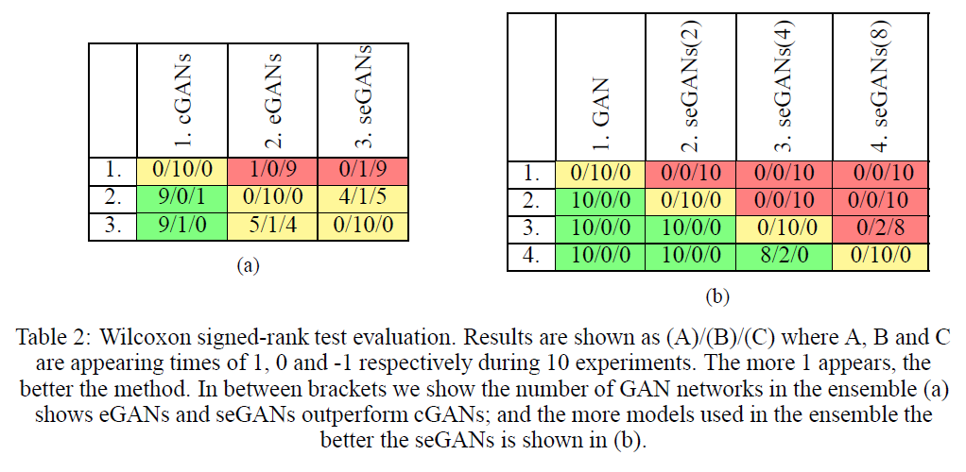

In a nutshell, eGAN has the similar result with seGAN but both better than cGAN, however seGAN need less computation than eGAN.

**AdaGAN:Boosting Generative Models (2017)**

**Ilya Tolstikhin1, Sylvain Gelly2, Olivier Bousquet2, Carl-Johann Simon-Gabriel1, and Bernhard Scholkopf1**

1Max Planck Institute for Intelligent Systems

2Google Brain

**Core idea:**

They propose an iterative procedure, called AdaGAN, where at every step we add a new component into a mixture model by running a GAN algorithm on a reweighted sample. (New G is constructed by a new-trained weak G and previous G)

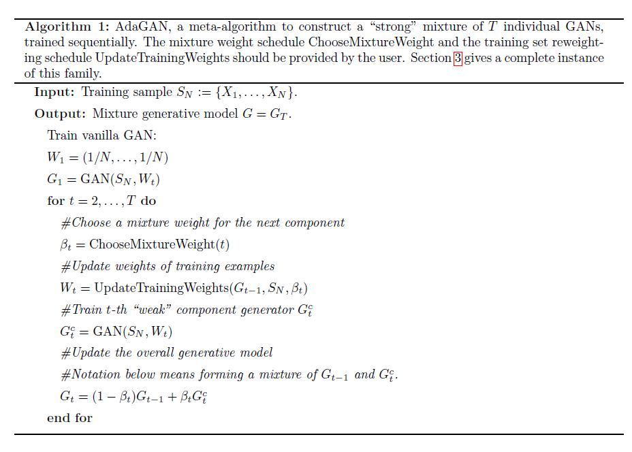

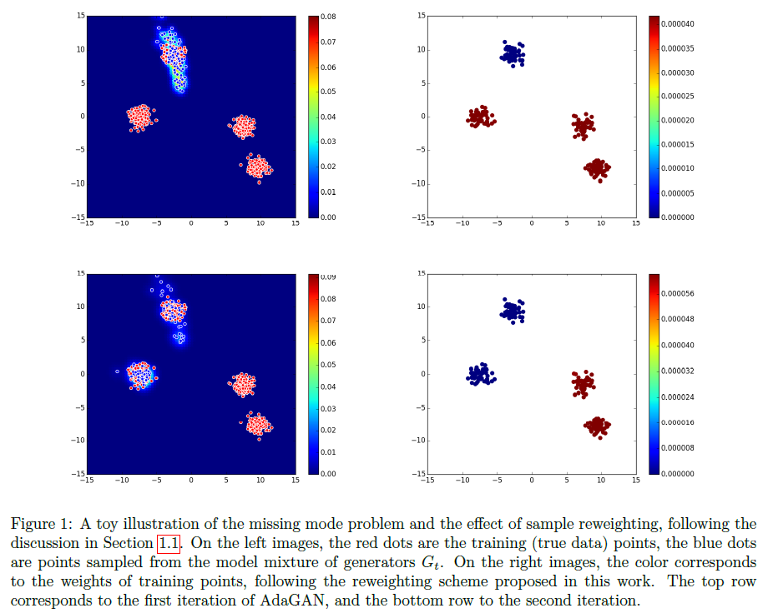

**Experiment (MINIST / MINIST3):**

Since this paper is theory-based, it just compare the convergence of their new algorithm with other models:

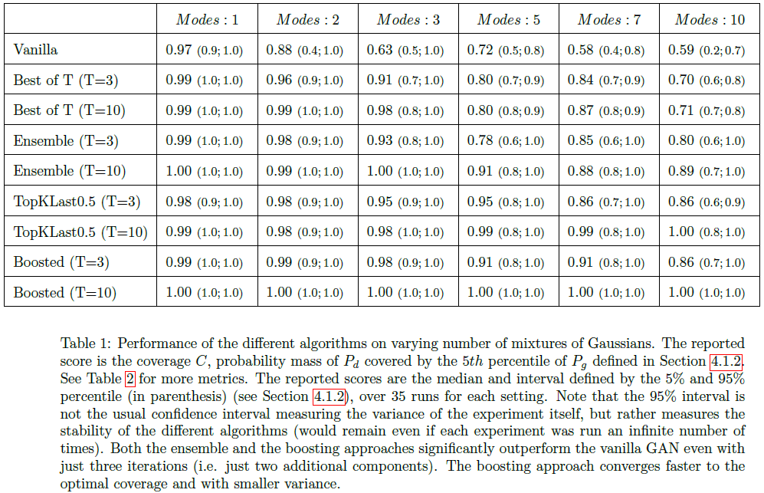

**Multi-Agent Diverse Generative Adversarial Networks (2018)**

**Arnab Ghosh, Viveka Kulharia, Philip H.S. Torr, Puneet K. Dokania, Vinay Namboodiri**

IIT Kanpur, India

University of Oxford, UK

**Core idea:**

Combine k generators and one discriminator to solve the mode collapse problem. Given the set of k generators, the discriminator produces a softmax probability distribution over k + 1 classes. The score at (k + 1)-th index (Dk+1(.)) represents the probability that the sample belongs to the true data distribution and the score at j belong to {1, ..., k}-th index represents the probability of it being generated by the j-th generator. The training goal is as follows:

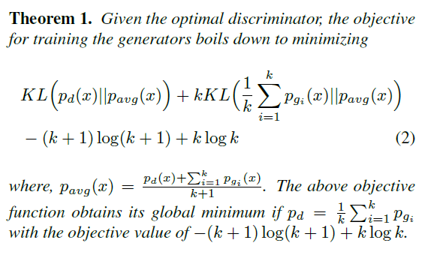

**Experiment (MINIST):**

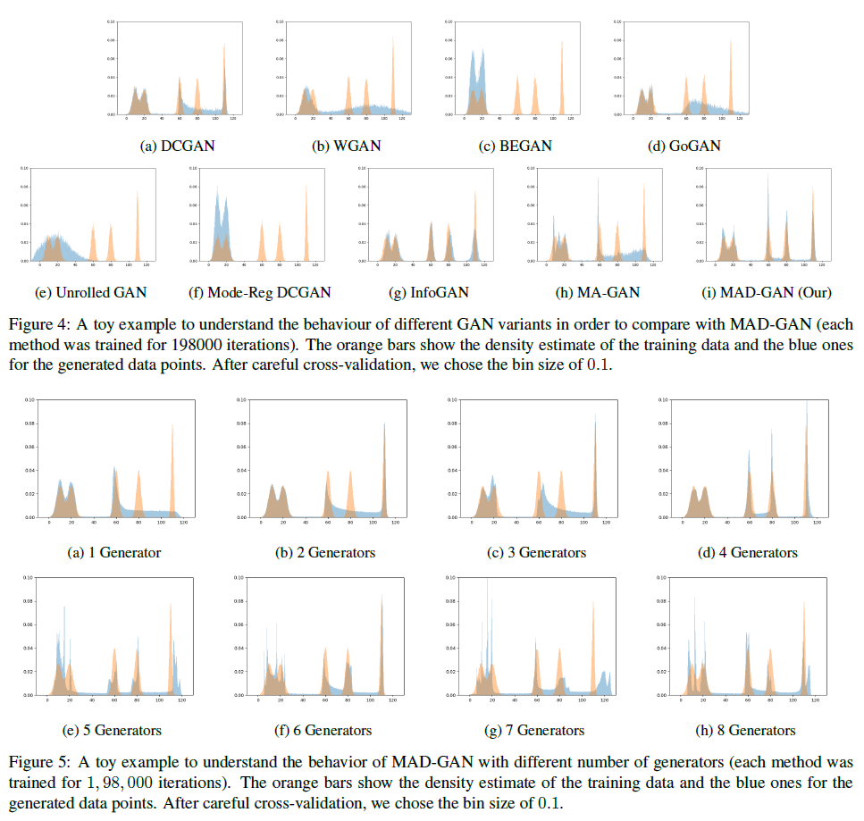

**GENERATIVE MULTI-ADVERSARIAL NETWORKS (2017)**

**Ishan Durugkar, Ian Gemp, Sridhar Mahadevan**

College of Information and Computer Sciences

University of Massachusetts, Amherst

**Core idea:**

1. A multi-discriminator GAN framework, GMAN, that allows training with the original, untampered minimax objective

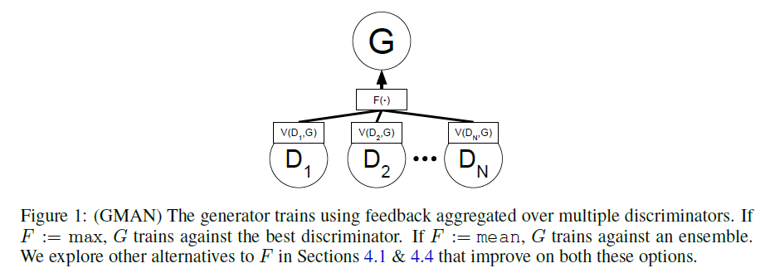

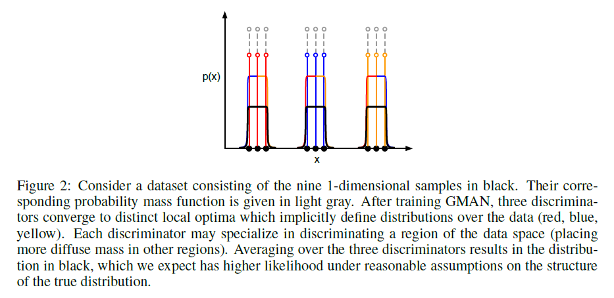

1. A generative multi-adversarial metric (GMAM) to perform pairwise evaluation of separately trained frameworks

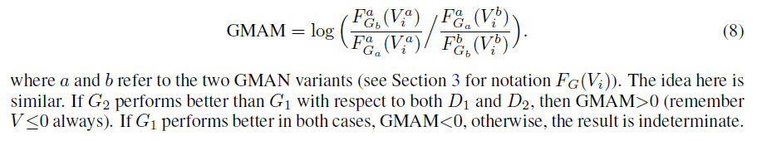

1. A particular instance of GMAN, GMAN*, that allows the generator to automatically regulate training and reach higher performance (as measured by GMAM) in a fraction of the training time required for the standard GAN model.

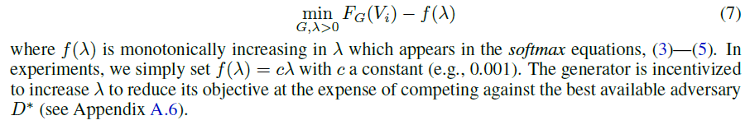

**Experiment (MINIST / CIFAR-10 / CelebA):**

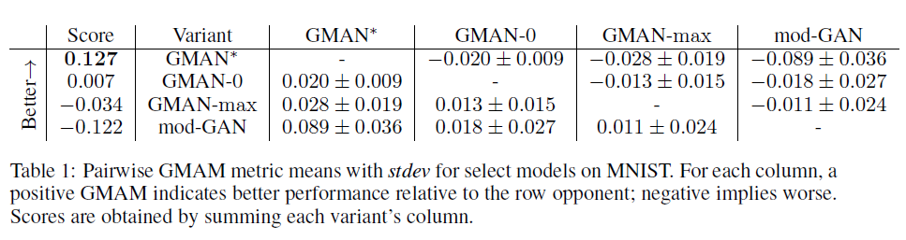

The result show The arithmetic softmax is controlled by the generator through λ get the best performance, which implies the importance of the decreasing factor.

**GANomaly: Semi-Supervised Anomaly Detection via Adversarial Training (2018)**

**Samet Akcay1, Amir Atapour-Abarghouei1, and Toby P. Breckon1,2**

Department of Computer Science1, Engineering, Durham University, UK

**Core idea:**

Similar with our paper

1. Generator + Encoder ---- similar with BiGAN
2. Anomaly Loss definition is also similar (NOT the Training Loss, theirs seems still the original Cross-Entropy Loss)

!!! In this paper, it seems the authors just combine the previous work but didn’t make some remarkable improvement such as the optimization of loss function(maybe their orientation is still towards image anomaly detection) or other contribution. What’s more, their definition of semi-supervised is that we only use normal sample to train initially and test with both normal sample and abnormal sample.

**Experiment (MNIST / CIFAR-10 / UBA / FFOB):**

MNIST

They experiment on MNIST data by treating one class being an anomaly, while the rest of the classes are considered as the normal class. In total, there has ten sets of data, each of which considered individual digits as the anomaly.

CIFAR10

They treat one class as abnormal and the rest as normal. Then detect the outlier anomalies as instances drawn from the former class by training the model on the latter labels.

University Baggage Anomaly Dataset | (UBA)

This sliding window patched-based dataset comprises 230,275 image patches. Normal samples are extracted via an overlapping sliding window from a full X-ray image, constructed using single conventional X-ray imagery with associated false color materials mapping from dual-energy. Abnormal classes (122,803) are of 3 sub-classes | knife (63,496), gun (45,855) and gun component (13,452) | contain manually cropped threat objects together with sliding window patches whose intersection over union with the ground truth is greater than 0:3.

Full Firearm vs. Operational Benign | (FFOB)

In addition to these datasets, they also use the UK government evaluation dataset, comprising both expertly concealed rearm (threat) items and operational benign (non-threat) imagery from commercial X-ray security screening operations (baggage/parcels). Denoted as FFOB, this dataset comprises 4,680 firearm full-weapons as full abnormal and 67,672 operational benign as full normal images, respectively.

